Ubuntu 20 function server-Patching-SOP
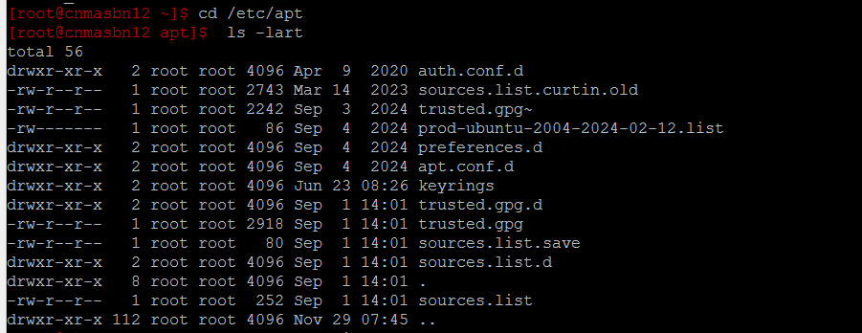
cat sources.list-commnet ot all lines
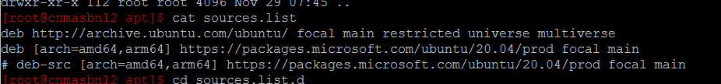
Go to sources.list.d
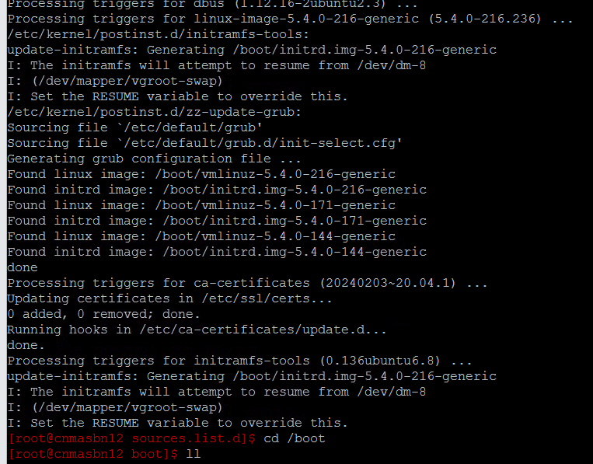
create old and move files if there no process running docker
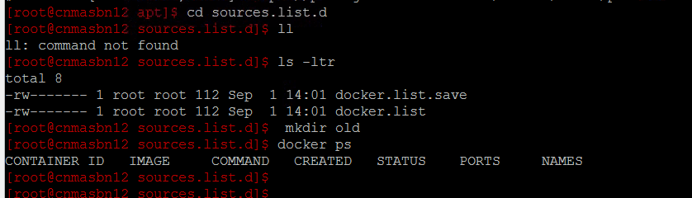
If you get certificate issue pls run below commands
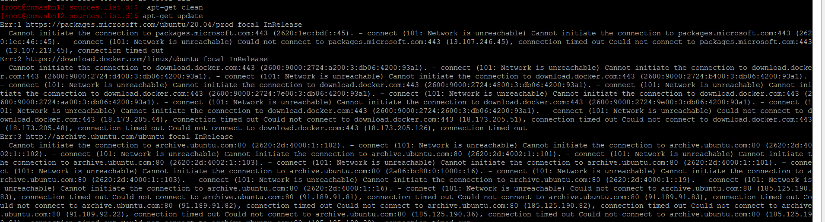
curl --insecure -o /usr/local/share/ca-certificates/BayerCA.crt https://byde005w15f.bayer.cnb/pub/ubuntu-BDC/BayerCA.crt
update-ca-certificates
------------
This is for functional server
Then yum update
$ wget https://byde005w15f.bayer.cnb/pub/ubuntu/sources.list.d/patching/ccpf-focal_20250901.sources --if its showing nay error add below commnad
wget https://byde005w15f.bayer.cnb/pub/ubuntu/sources.list.d/patching/ccpf-focal_20250901.sources --no-check-certificate
Enterprize zone:
wget https://byrsat6.de.bayer.cnb/pub/ubuntu/sources.list.d/patching/focal_20250901.sources
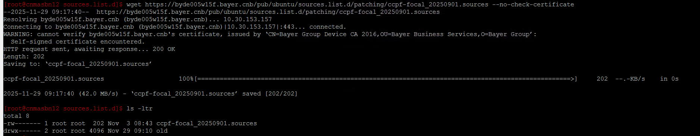
yum upgrade
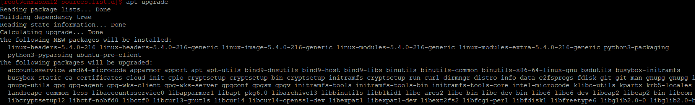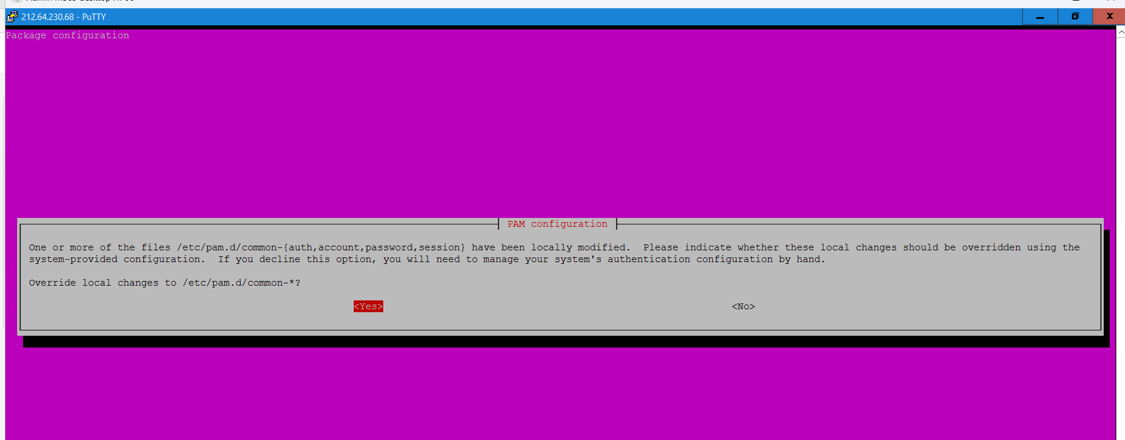
It will show NO as default let is be and give enter
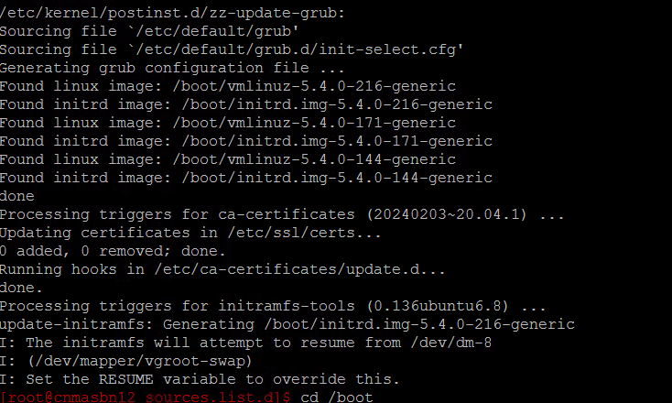
once updated pls check in boot and image
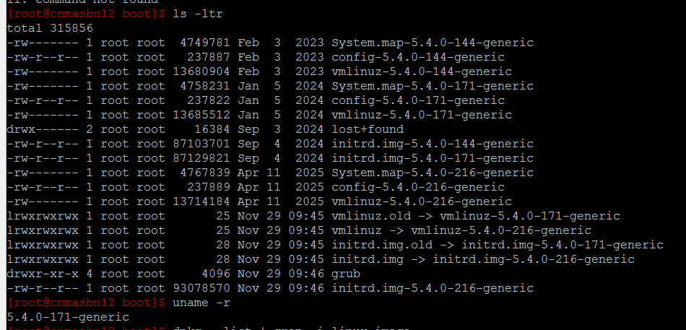
dpkg --list | grep -i linux-image

